Software Design Document

Project-1

Event Planning



|  |  |
| --- | --- |
| Prepared by:  Ankita Rao (PCE15IT006)  Ayushi Sharma (PCE15010) | Guide:  Ms. Shazia Haque  Associate Professor,  Deptt of Information Technology |
| Department of Information Technology,  Poornima College of Engineering | |
| Session – 2018-19 | |

|  |  |
| --- | --- |
| Table of Contents | Page No. |
| 1. Introduction | 3 |
| **2. Architectural Design (System Flow Chart)** | 4 |
| **3. UML Diagram (Class Diagram, Activity Diagram, Use Case Diagram)** | 6 |
| **4. Database Diagrams** | 13 |
| **5. API Specification** | - |
| 6. GUI Design | 15 |
| 7. Glossary | 16 |
| 8. Appendices | 17 |
| 9. References | 18 |
| 10. Guide’s Comments | 19 |

**INTRODUCTION**

## 1.1 Purpose

The purpose of the project is to provide a system to manage all the events which the team or individual wants in near future in order to help users for suitable planning of Event. The main objective of the Project on Event Planning System is to manage the details of Event, Booking, Customer, Employee, and Volunteer. It manages all the information about Event, Package, and Enquiry. The project is totally built at administrative end and thus only the administrator is guaranteed the access. The purpose of the project is to build an application program to reduce the manual work for managing the Event, Booking, Package, and Customer. It tracks all the details about the Customer, Employee, and Enquiry.

**1.2 Feasibility**

**1.2.1 Operational Feasibility**: Operation of the proposed system depend on its various users. These various user-types mentioned below.

* Admin
* Manager
* Normal User(Participants)/Volunteer

Admin will make managers for different events. And allocate Login ID.

Thereafter Normal User enters their details like Name, Event, Venue, number of guest. Then manager will check user entries and will allot registration id for authentication purpose .Here manager responsible to check team size, details, manager is responsible to restrict unauthorized people or wrong entries.

**1.2.2 Social Feasibility**: Proposed system would be acceptable by the other

people. Because Online Event Planning is better than ordinary registration

process and management in the following issues:

* Faster than other older systems
* Database keeps records
* Time saving

**Architectural Design**

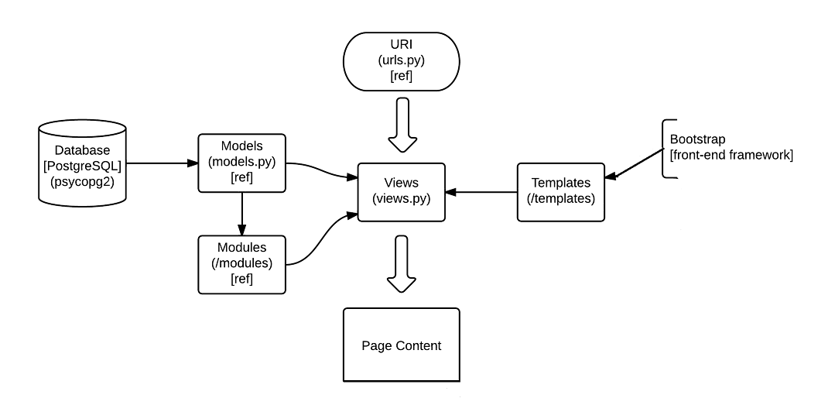

Figure 1 - Architectural Diagram

**Work Flow Diagram:**

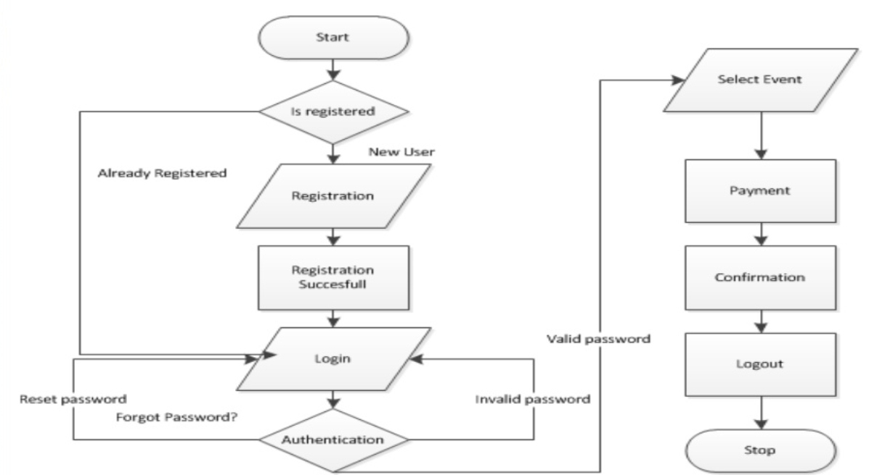

Figure 2 - Work Flow Diagram

**UML Diagram**

* Use Case Diagram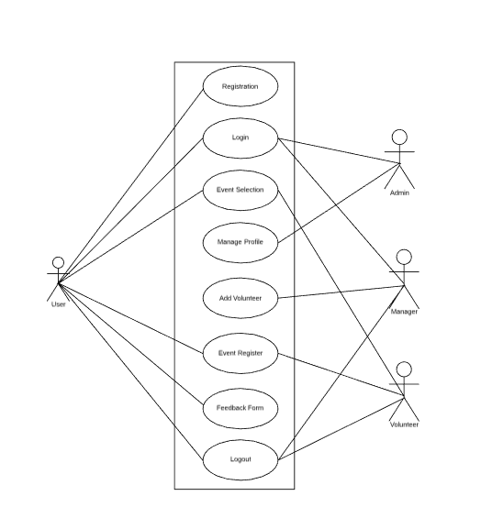

Figure 3 - Use Case Diagram

* Class Diagram

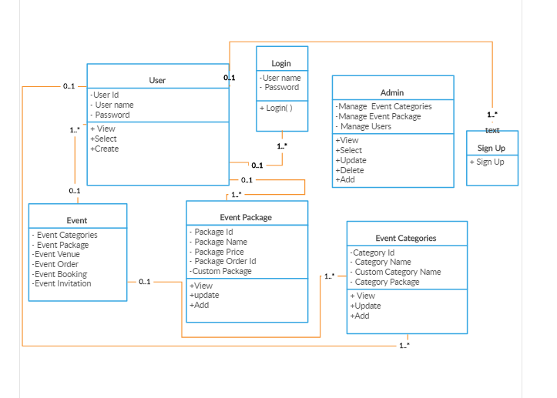

Figure 4: Class Diagram

* Activity Diagram

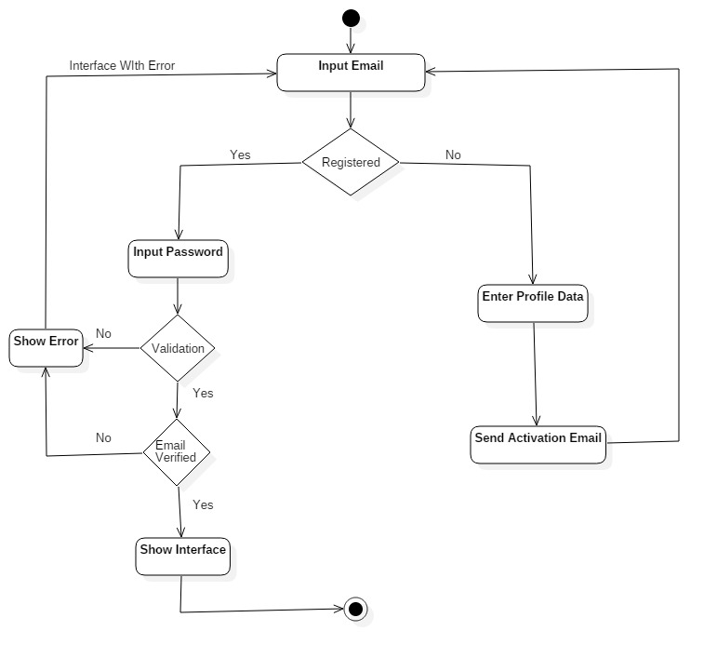

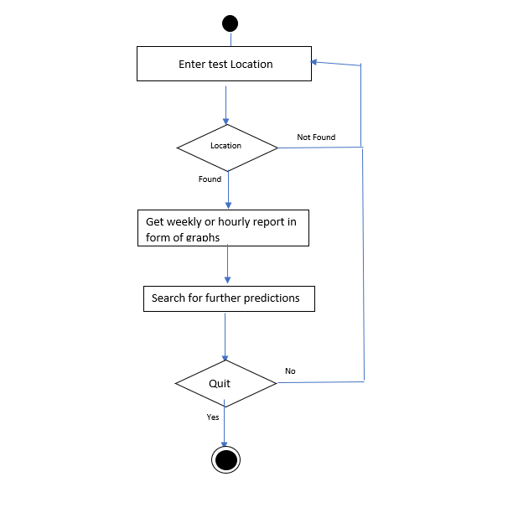

Calculate cost of event and Book the event

Enter all the requirement for the events with guest details.

Venue and

Enter Event and Venue

Figure 5: Activity Diagram

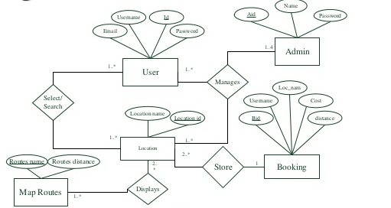

**Entity Relationship Diagram**

Figure 6: ER Diagram

**Sequence Diagram**

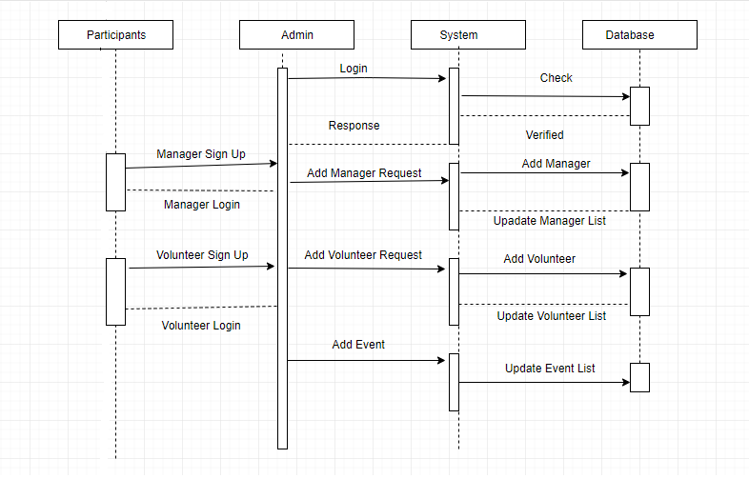

Figure 7: Sequence Diagram

**Database Diagrams**

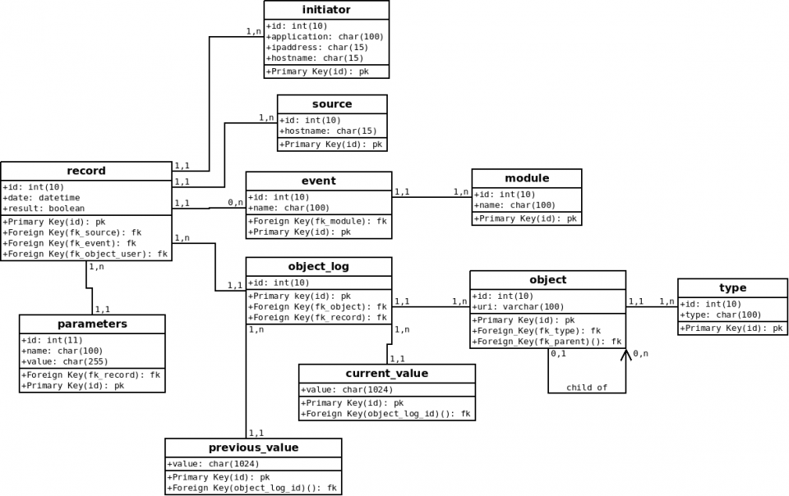

Figure 8: Database Diagram

1. **Order Table**

|  |  |  |  |  |  |  |  |  |
| --- | --- | --- | --- | --- | --- | --- | --- | --- |
| **Fields** | Id | Date  Created | Date modified | Price | Amount paid | Discount | Purchase date | Payment date |
| **Datatype** | Int | Date | Date | Int | Int | Int | Date | Date |

1. **Event Table**

|  |  |  |  |  |  |  |  |  |
| --- | --- | --- | --- | --- | --- | --- | --- | --- |
| **Fields** | Id | Event name | Organiser | Sponsor | Start date | End date | Last date of register | Description |
| **Datatype** | Int | Varchar | Varchar | Varchar | Date | Date | Date | Char |

1. **Ticket table**

|  |  |  |  |  |  |  |  |  |  |
| --- | --- | --- | --- | --- | --- | --- | --- | --- | --- |
| **Fields** | Id | Event name | Title | First name | Last name | Mobile no | Ticket type | Price | Discount |
| **Datatype** | Int | Varchar | Varchar | Char | Char | Int | Char | Int | Int |

**GUI Design**

**1.**

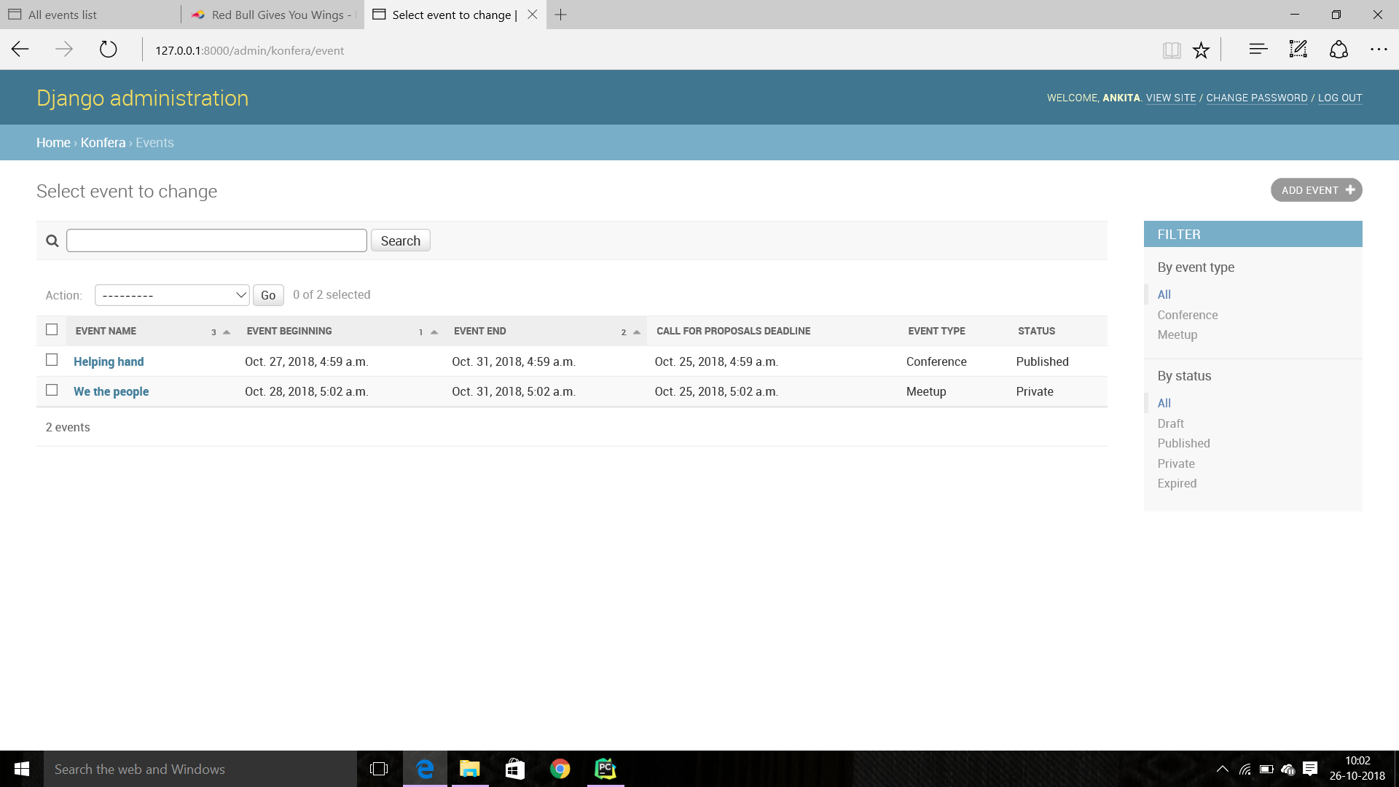

Figure 9: GUI Diagram 1

**2.**

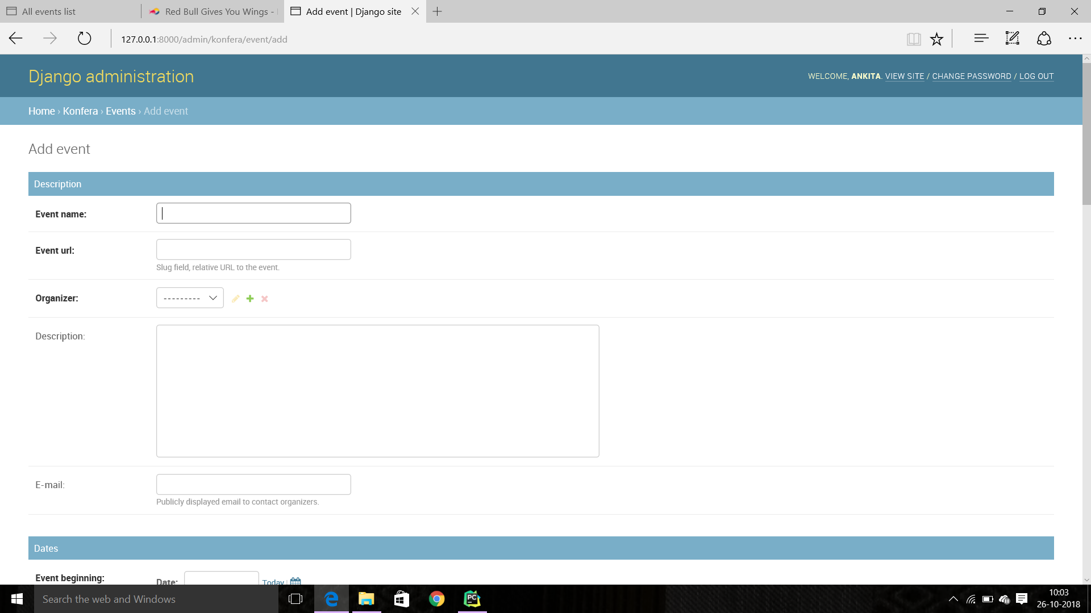

Figure 10: GUI Diagram 2

# **Glossary**

There is no as such abbreviations involved in the SDD .The term user in the SDD refers to the individual or team of school, college or family for event booking.

**Appendices**

**Appendix 1: Site/Venue Checklist**

The following is a checklist and form that may help you in (1) selecting a venue, and (2) making sure the venue you have chosen fulfils your needs (or what to do when it does not meet your needs).

|  |  |
| --- | --- |
| 1. | Name of Venue |
| 2. | Address |
| 3. | General Manager |
| 4. | Other Contact Person |
| 5. | Contact Telephone |
| 6. | Contact Email |
| 7. | Distance from Airport(s), Train and Bus Stations, highways Put a checkmark before each item below and any comments after the item. |
| 8. | Free/Paid Parking |

**Appendix 2: Evaluation Form**

A Simple Version   
1. What did you like or find most useful about this event?   
2. What did you like or find least useful about this event?   
3. Any other comments or suggestions?

# **References**

1. “Django Design Patterns and best Practices”, A. Ravindran, 2nd Edition, Packt Publishing
2. “Django for Beginners: Learn Web Development with Django 2.0”, W.S. Vincent, Independently published, 2018
3. “Django By Example”, A. Mele, Packt Publishing
4. “HTML & CSS: Design and build Websites”, J. Duckett, 2011, Wiley
5. https://www.mpiweb.org/events/experiential

# https://www.w3schools.com/python/python_pip.asp

**Guide’s Comments:**